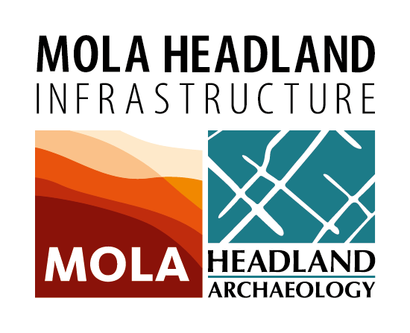

Job Description

Job Title: | Senior Community Archaeologist  MOLA Headland Infrastructure is an ambitious archaeological consortium with long term prospects for infrastructure work throughout the UK.
Job Reference: | CA-A14
Department | MOLA HEADLAND Infrastructure
Salary | £22,600–£26,000
Hours: | 37.5 hours per week (Flexible days of work between Monday to Sunday). Flexibility with working hours will be required.
Location: | The post is based at Mola Headland Infrastructure Project office at St. Neots and on various locations along the scheme (Cambridge to Huntington). Flexibility with regard to travel will be necessary.
Duration: | Fixed Term – 1 year
Responsible to: | MOLA Headland Infrastructure public engagement and communications managers for the A14 project
Responsible for: | Archaeologists as appropriate when preparing and delivering events. Supervision of volunteers as required.
Overall Job Purpose: | To develop, manage and deliver a programme of community engagement around the archaeological works taking place as part of a major road scheme in Cambridgeshire (A14 Cambridge to Huntingdon improvement scheme).
Key Result areas: | - To deliver the key targets of the engagement programme as agreed between Highways England and MOLA Headland Infrastructure  - To liaise with the project’s field personnel in order to gather content and facilitate engagement programmes  - To organise, coordinate and deliver successful and popular events required for the public engagement programme  - To devise content for MOLA’s Time Truck displays or other travelling exhibitions  - To write timely and appropriate content for social media, the project’s blog and other media reporting on the progress of work in keeping with the agreed client protocols  - To regularly report and share project outcomes with relevant internal and external partners  - To coordinate the work of the MOLA Time Truck Education Officer on the A14 project including liaising with schools regarding bookings  - To engage, develop and maintain links with local audiences, including local historical and archaeological societies  - To be responsible for undertaking any administration required to ensure delivery of project objectives  - To be professional and to uphold the standards, values and reputation of MOLA Headland Infrastructure in all team, client and public interactions  - To work in accordance with the requirements of the MOLA Headland Infrastructure’s Health and Safety Policy
Working Conditions | - Travel within South Cambridgeshire including occasional extended stays away from the primary base  - Weekend and evening working will be required
Special Circumstances | - A Disclosure and Barring Service (DBS) Check will be required as the role may involve working with vulnerable adults. A criminal record may not be a bar to employment but any decision will be treated on its merits and individual circumstances subject to MOLA’s overriding obligations to protect children and other vulnerable members of the communities
Continuous Professional Development | We are committed to supporting and providing CPD for successful candidates. We expect all employees to undertake available training and research to enhance personal knowledge, skills and experience

NB This job description should not be taken as an exhaustive description of the role and is, rather, indicative of the types of responsibility covered by this job. Post holders will be required to carry out such other work as is required by MOLA Headland Infrastructure as long as this is reasonable and commensurate with the nature of the post held.

Last updated: February 2017

Person Specification

 | Essential | Desirable | Assess. Method
Qualifications
 | Degree in archaeology or equivalent discipline or experience | Further degree in relevant discipline | AF
 | CSCS card or willingness to train and take the test | Membership of a relevant professional body i.e. IFA | AF
 | Full driving licence and willingness to drive company vehicles |  | AF
Experience & Knowledge
 | Knowledge of archaeology of Iron Age/Roman Britain | Current knowledge of archaeology in Cambridgeshire
 | Substantial experience working with community archaeology groups or projects | Experience of supervising archaeology projects | AF/I
 | Experience of event management, organising workshops and conferences |  | AF/I
 | Experience of public speaking |  | AF/I
 | Experience of social media/blogs/publicity campaigns
 | Demonstrable experience of working in multi-disciplinary teams to deliver projects within time and budget constraints | Experience of project evaluation | AF/I
 | Experience of teaching to both specialist and non-specialist audiences |  | AF/I
Skills/Abilities/
Competencies
 | Ability to work under pressure and to tight schedules | Familiarity with CAD | AF/I
 | Ability to work independently and manage a diverse programme of responsibilities | Familiarity with design programmes such as the Adobe Creative Suites package | AF/I
 | •The ability to design learning materials including digital media, audio-visual displays, artefacts | Familiarity with website CMS, SEO, social media scheduling and monitoring | AF/I
 | Strong organisational, interpersonal and communication skills | Ability to create and manage GIS projects | I
 | Familiarity with the use of social media (Facebook, Twitter, Flickr) | Familiarity with database systems such as Access | AF/I
 | Ability to network and connect with stakeholders from a range of fields | Experience of developing AV content for web or other media | AF/I

Assessment Method Code:
AF – Application Form
I – Interview

